**LAB 1: VARIABLES AND DATA TYPES**

TASK 1 DECLARING VARIABLES.

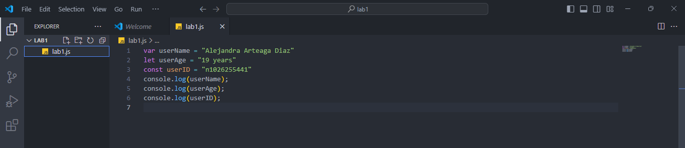

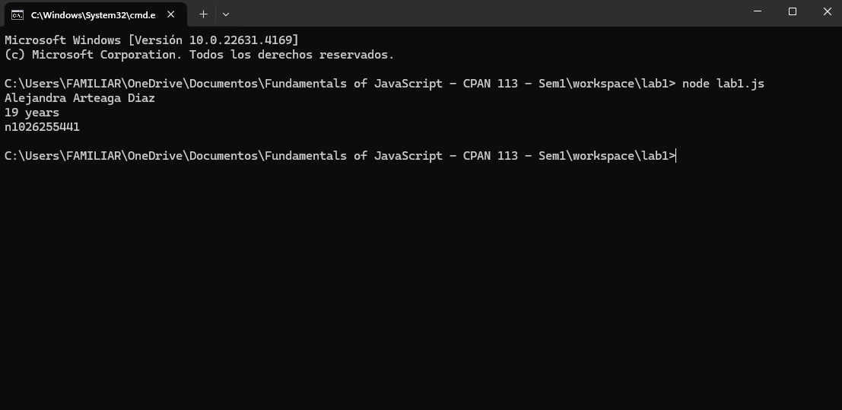

Teacher I removed the ‘years’ in the userAge. I realized about it a few minutes later.

TASK 2 UPDATING VARIABLES

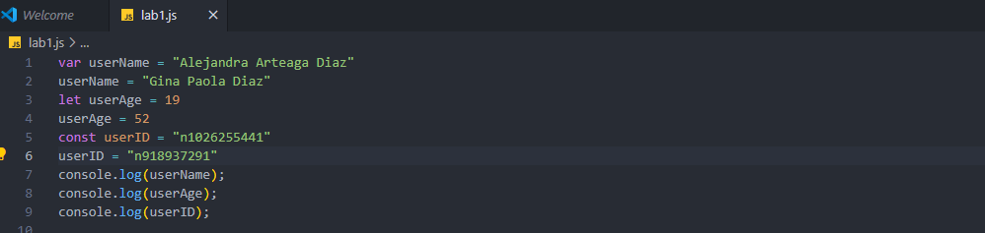

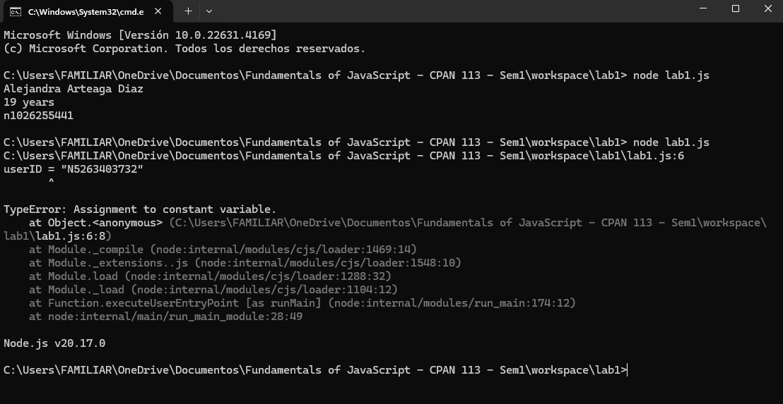

The command prompt displays an error because we are changing the constant variable and it is a variable that can not be changed.



If we keep the userID constant, the system will show us the username and userAge information updated due to they are variables (changing information).

TASK 3 WORKING WITH DIFFERENT DATA TYPES

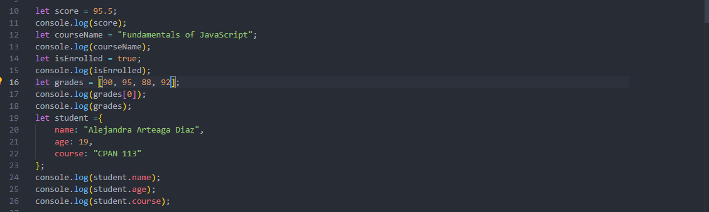

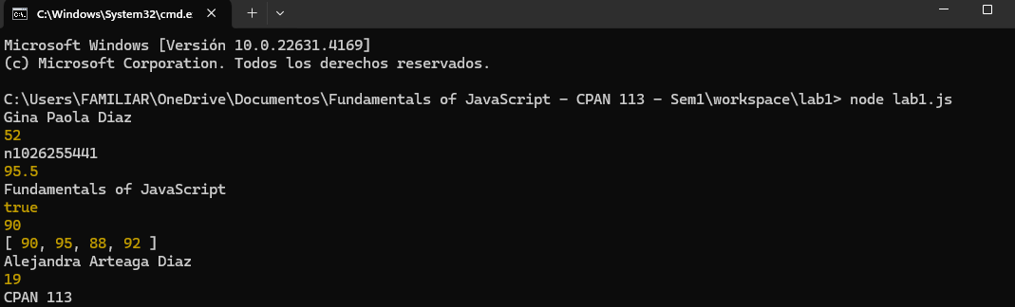

TASK 4 ARITHMETIC OPERATIONS



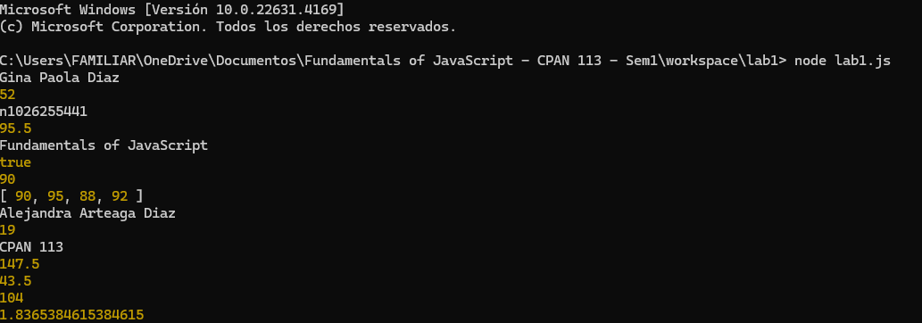

TASK 5 COMPARISON OPERATIONS

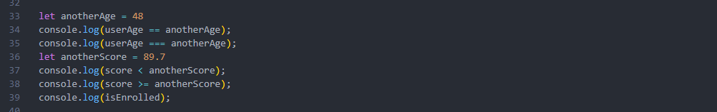

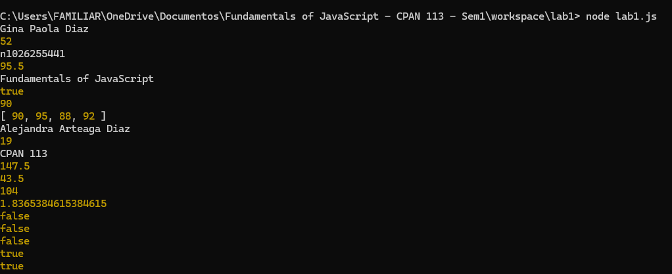

TASK 6 CONDITIONAL STATEMENTS

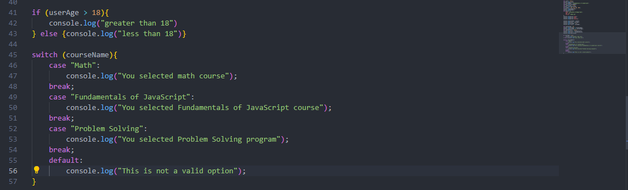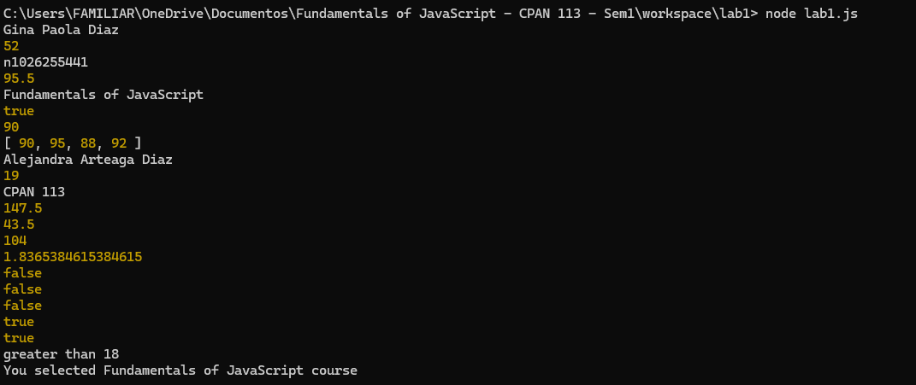

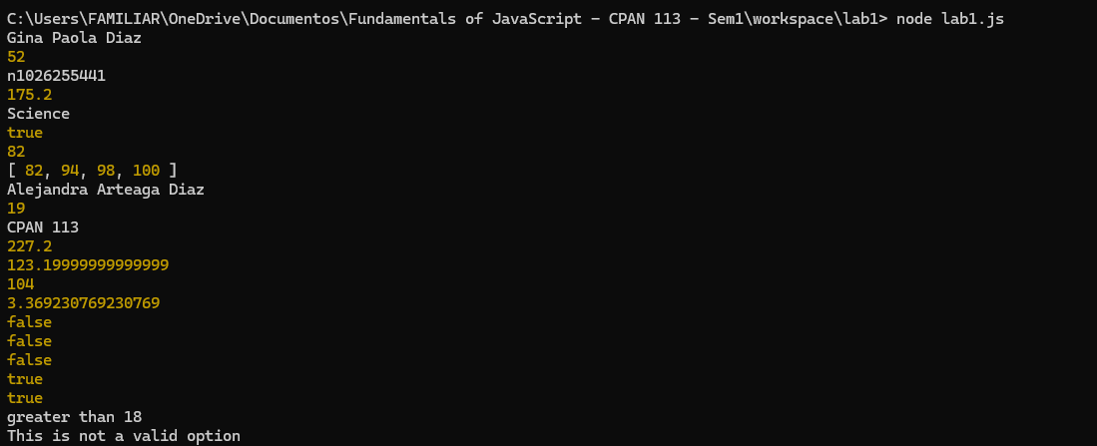

If we select a program that is not listed.